Bootstrapping windows system as Chef-client

1)Take one windows system from AWS

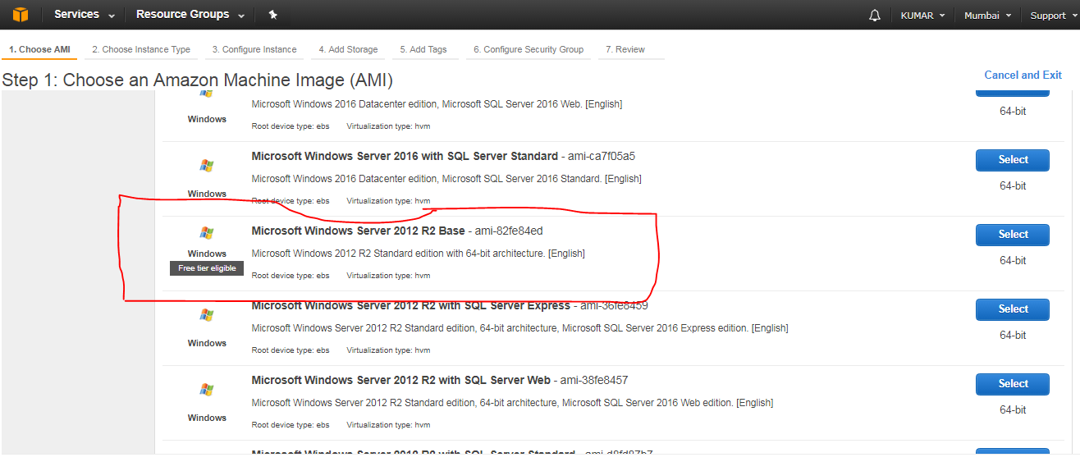

2) While launching the windows machine make sure in security groups RDP, WINRM-HTTP, WINRM-HTTPS ports are opened to ANYWHERE.

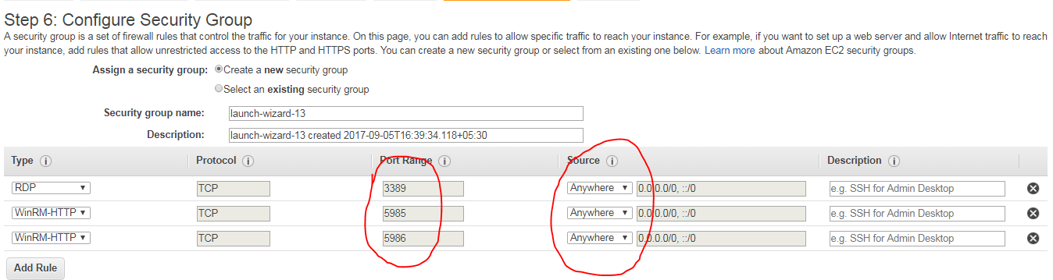

3) Before bootstrapping windows machine,

i) Log into windows machine (aws) and go to Control Panel and click on System and Security

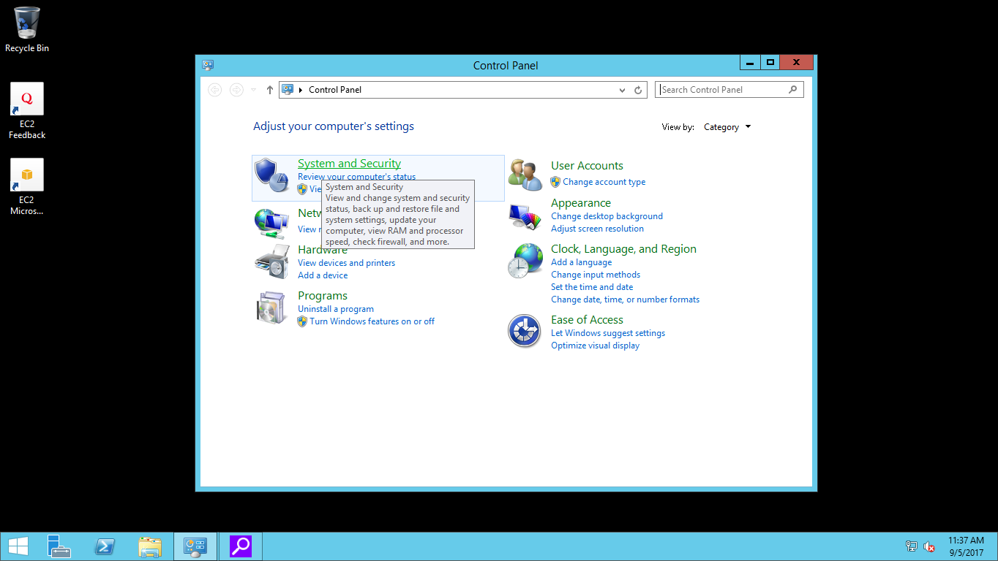

ii) Now Click on Windows Fire Wall

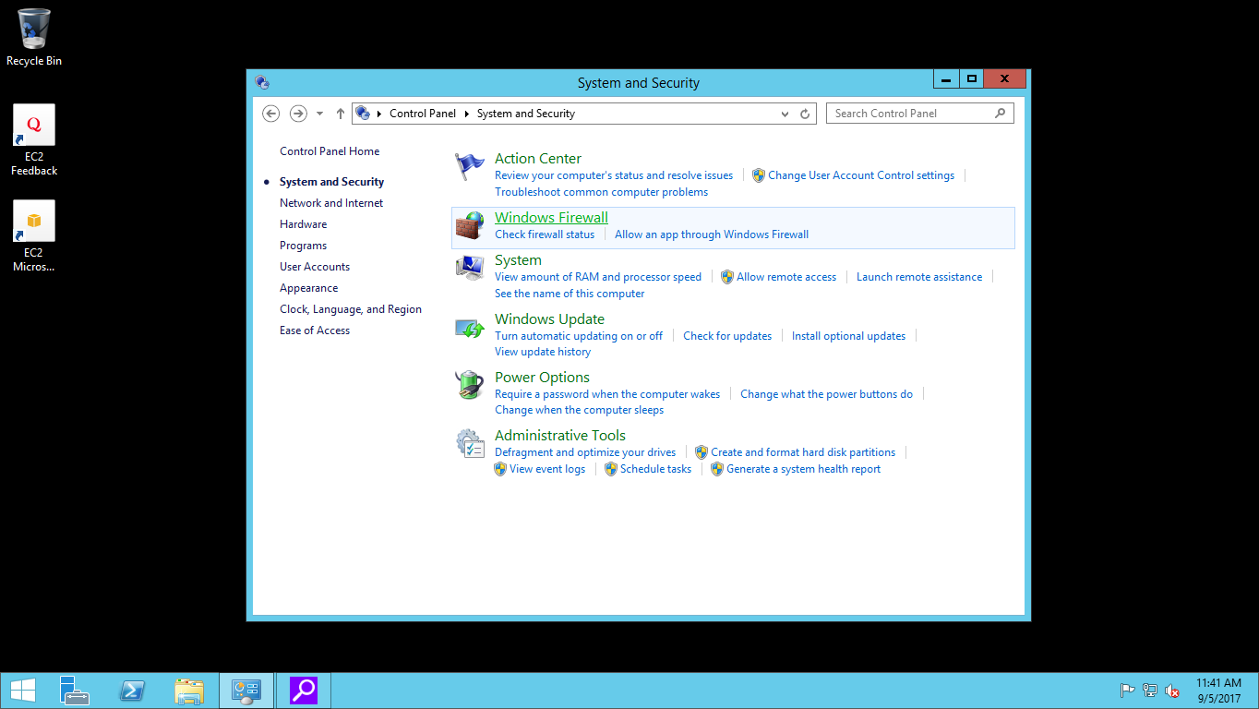

iii) At the left side click on “Turn Windows Fire Wall On or Off”

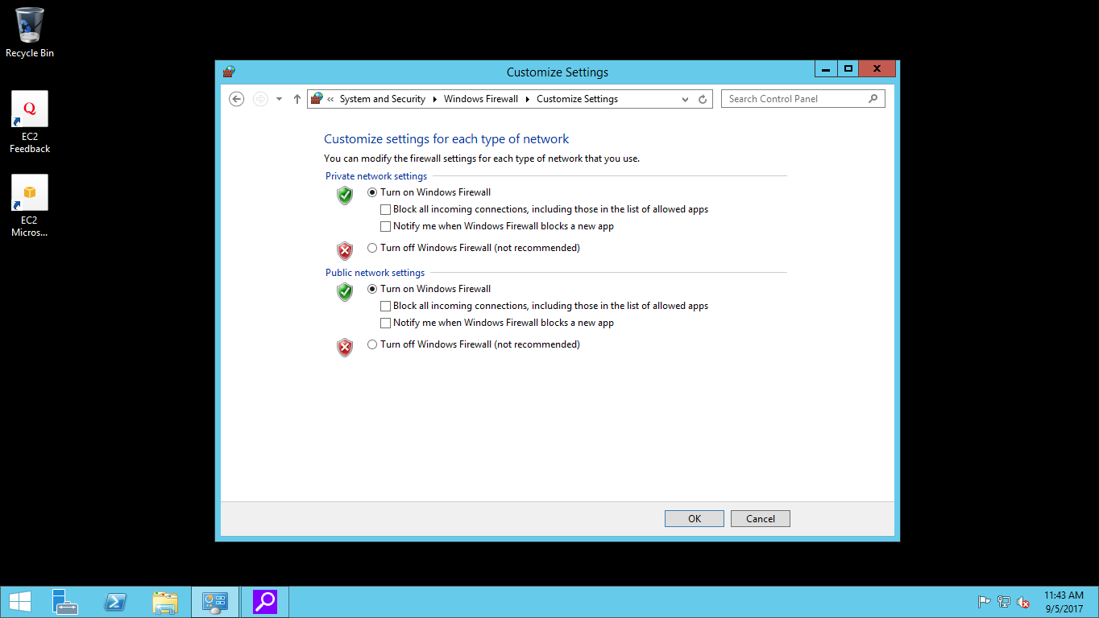

iv) Now Select “Turn off Windows Fire Wall “option in both Public network settings and private network settings and click on ok. Minimize aws machine.

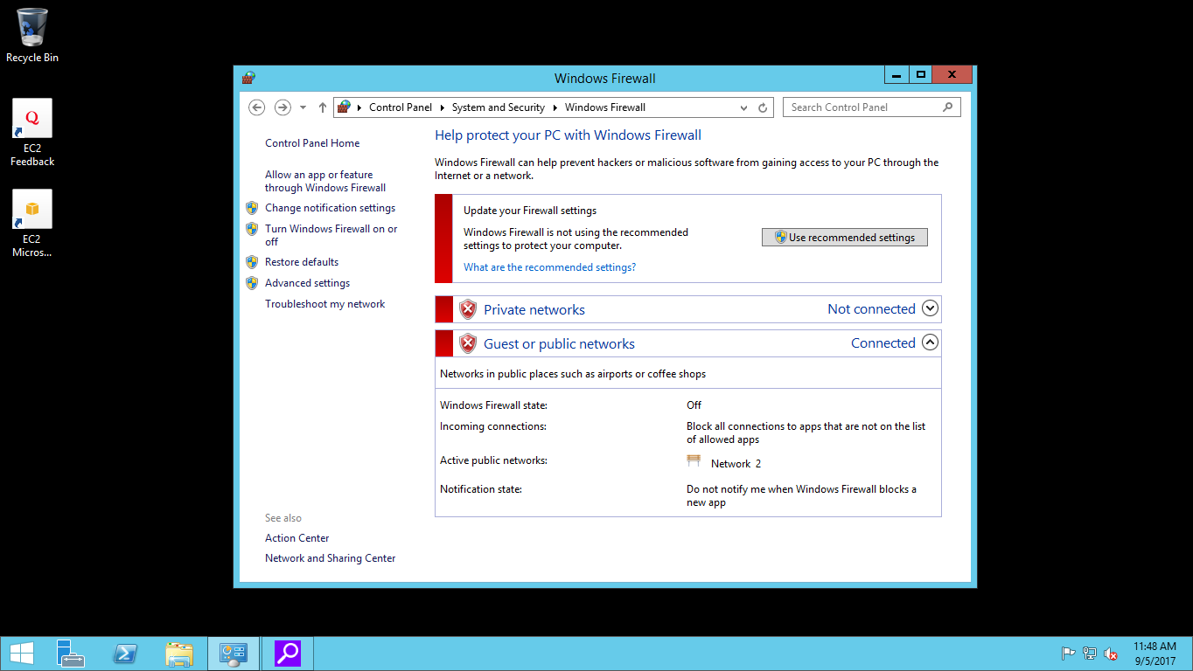

4) Now go to Workstation and bootstrap windows machine (aws) by using the below command.

Knife bootstrap windows winrm ip –x username –P “password” –N”nodename” –r”recipe[cookbookname]”

Ex:

knife bootstrap windows winrm 192.168.3.4 -x Administrator –P “aduyt123” –N”node1” –r “recipe[kumar]”

5) I created a cookbook by the name “SAMPLE”. It contains a code to create a sample file in windows machine after bootstrapping.

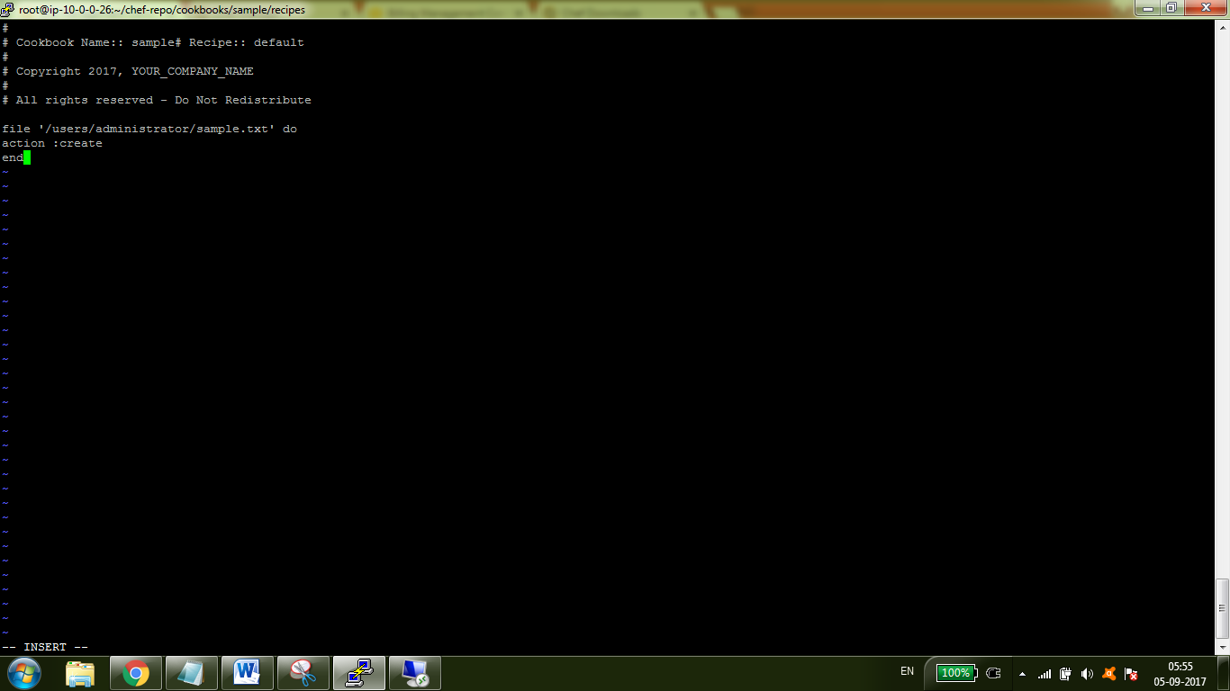

6) After uploading the cookbook to server, now I am bootstrapping windows machine (aws)

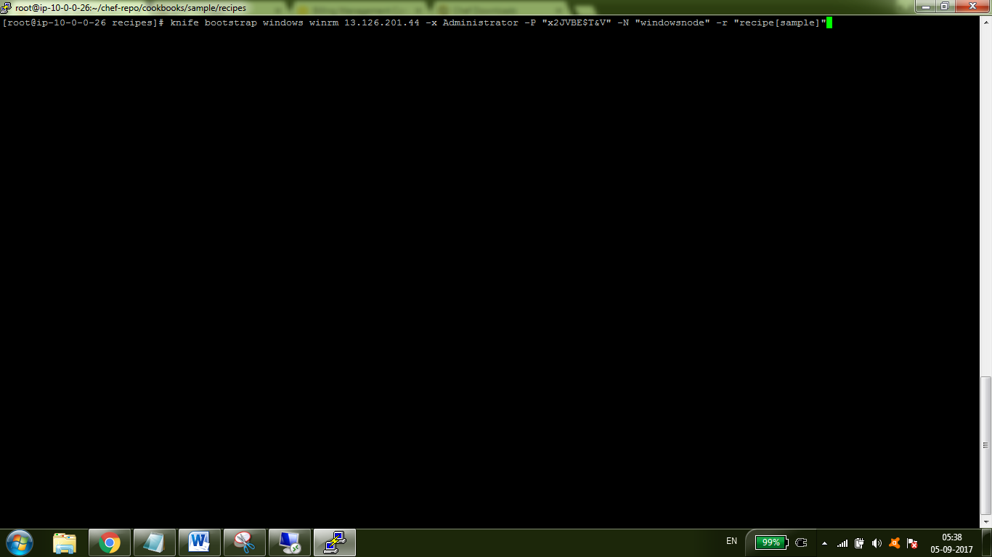

7) At the time of bootstrapping

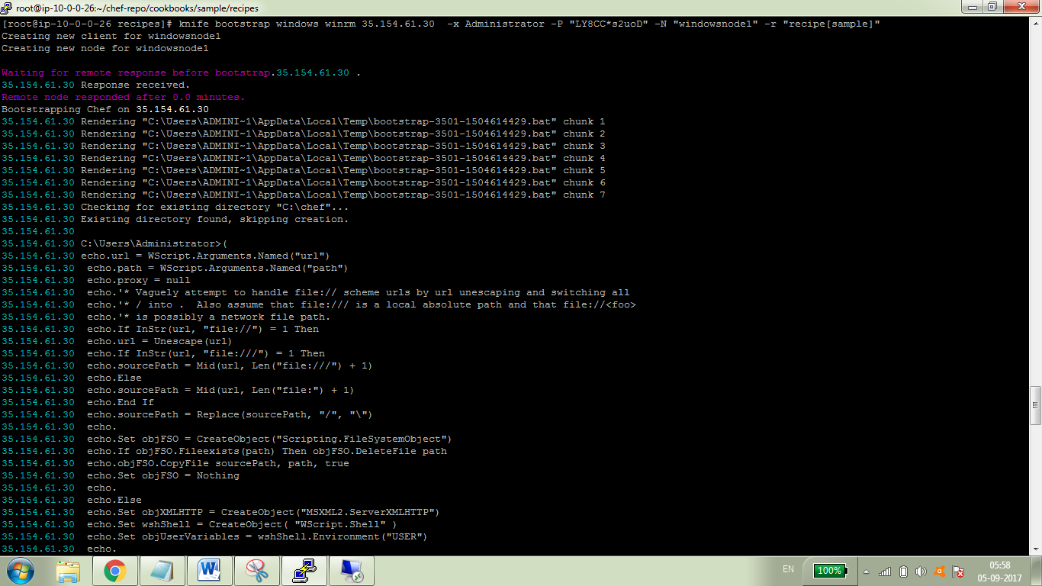

8) It created one sample file with name “sample.txt” at users/administrator in windows machine.

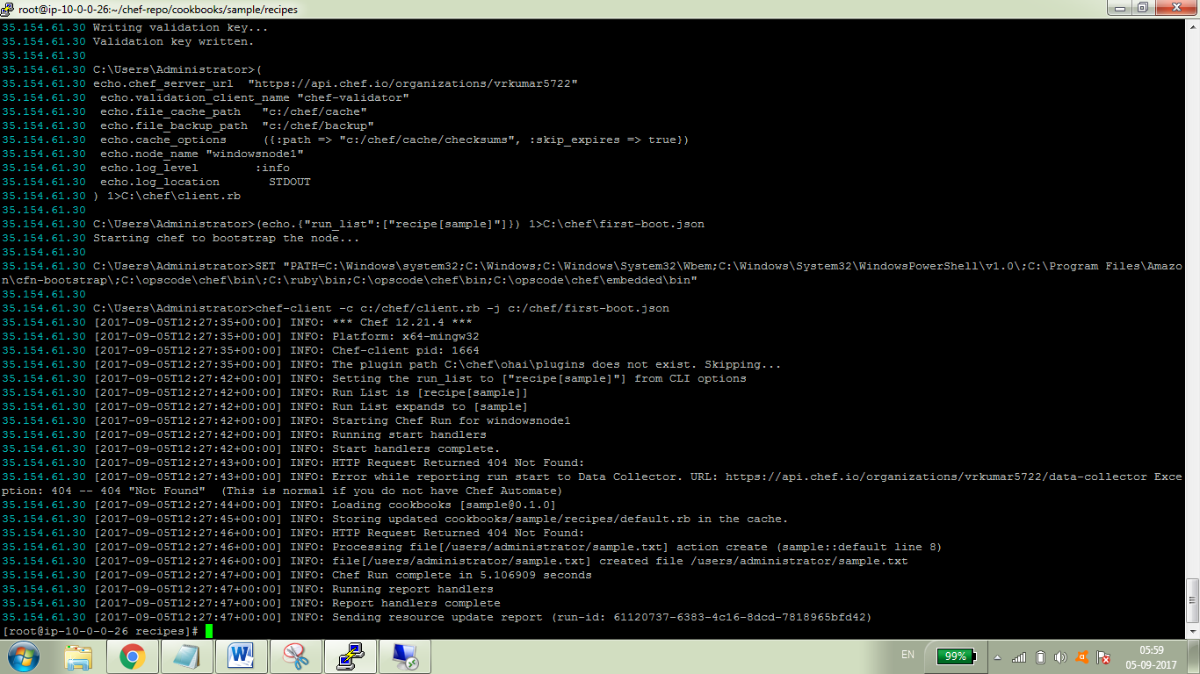

9) In windows system file is created

